**(22) Tropical Cyclone**

Condition favorable for the formation of tropical cyclone

1. A large area of water surface with temperatures above 27 degrees Celsius
2. Coriolis force should be strong enough to from the cyclonic votex.
3. A week low pressure area or low-level cyclonic circulation which already exists on the ocean surface can reinforce and turn into a tropical cyclone.
4. There should be divergence around the 9 to 15 km. which sucks the air from the ocean surface above and thus the low pressure at the surface is strengthened.
5. Variation in the vertical wind speed is minor, this is referred to as low wind shear.
6. The tropical cyclone developed around the ITCZ

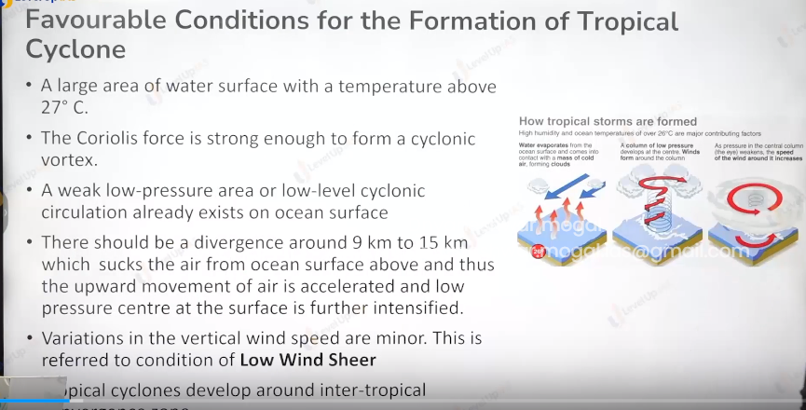

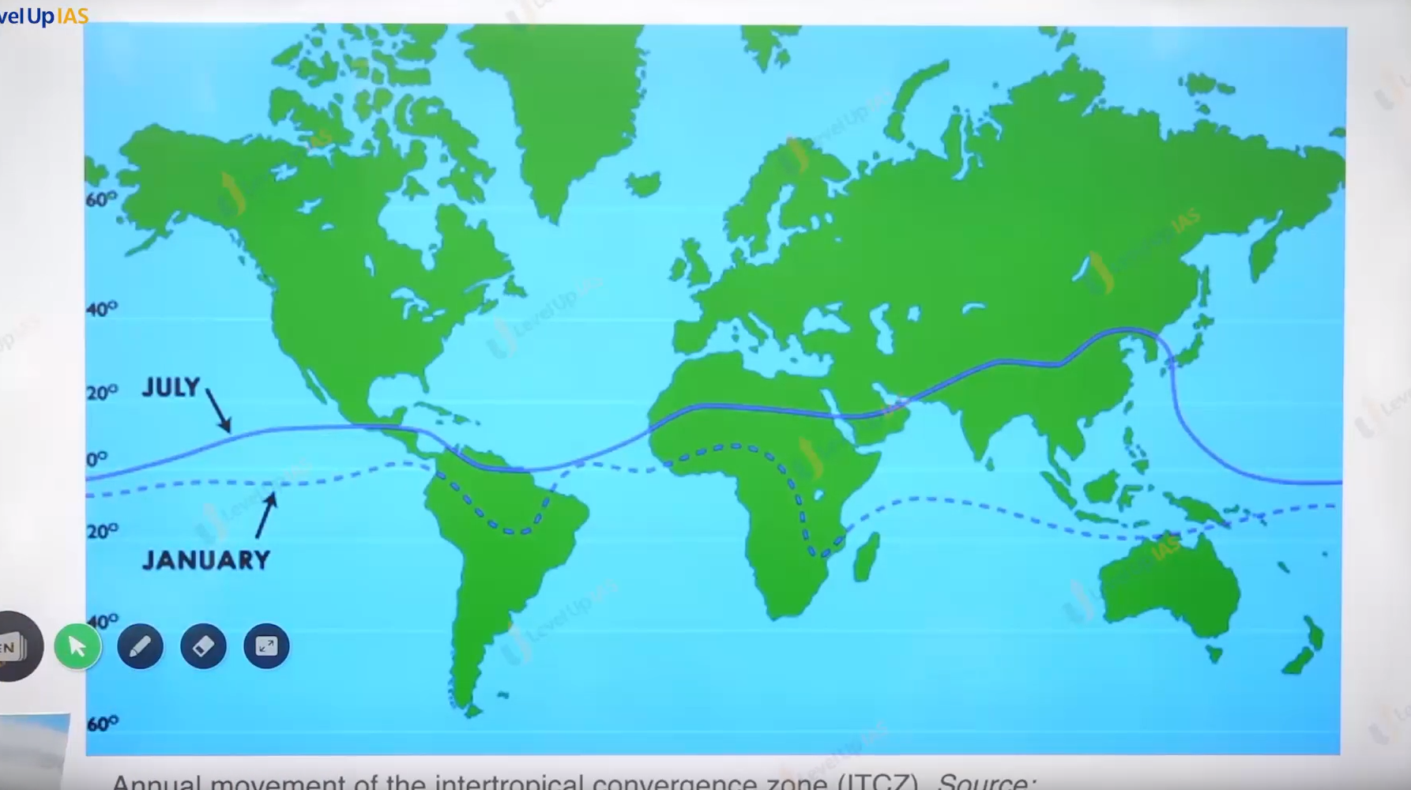

Origin of the tropical cyclone

1. Tropical cyclone arised over the tropical ocean in the late summer and have a themermal origin (September to mid november).
2. Because of coriolis effect convectinal current takes warpool type motion.
3. The tropical cyclon formed and moved under the influence of trade winds towards the land.

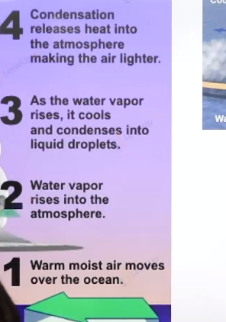

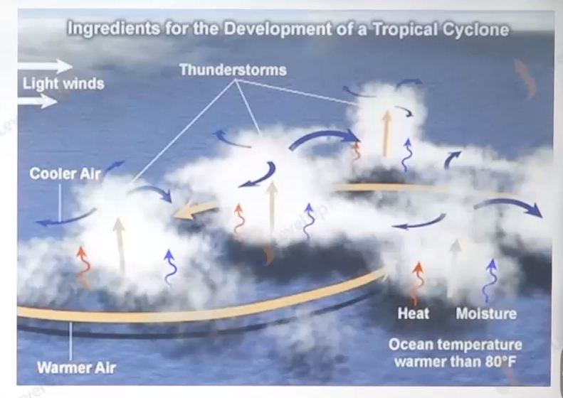

Stages of formation and initial development:

1. Trasport of water vapour and heat from the warm ocean to the overline air largely thourgh evaporation.
   1. Form the sea surface, this leads to creations of cyclonic strom.
   2. Condasation of raising air releasing the heat and keep the entire column warm.
2. Mature stage:
   1. raising air intensify as the tropical strom and spreads horizontally at tropo pause. When the air spreed some portion of air migrage downwards and subsides in the eye.
   2. When the air experiences subsedance the air compressed which increases the temperature. This leads to creation of warm eye.
   3. The sinking air in the eye does not reach the ocean surface but reaches only upto a depth of 1 to 3 km.

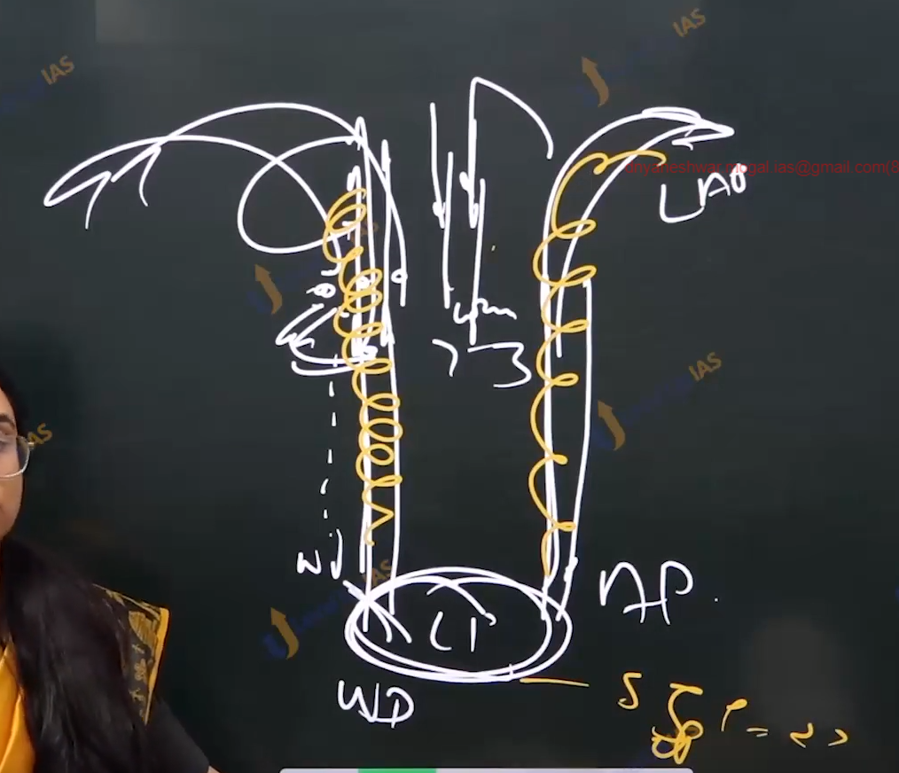

1. End of cyclone :
   1. As soon as the source of warm moist air abuptly cutoff tropical cyclon become weaken, on reaching the land moister suppies is cuttoff .
   2. The place where the tropical cyclone crosses the coast it called as land fall of cyclone.

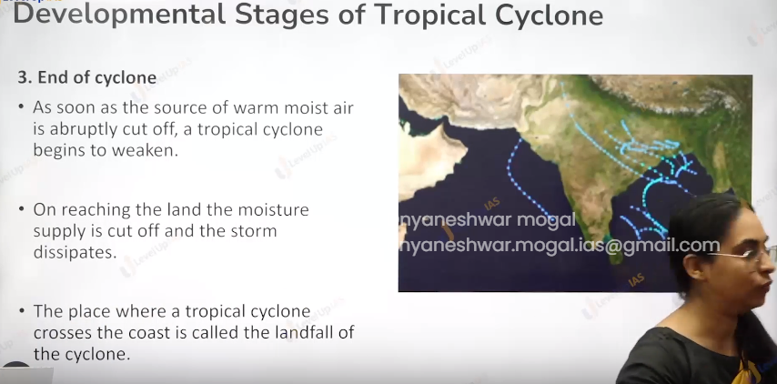

Structure of tropical cylone:

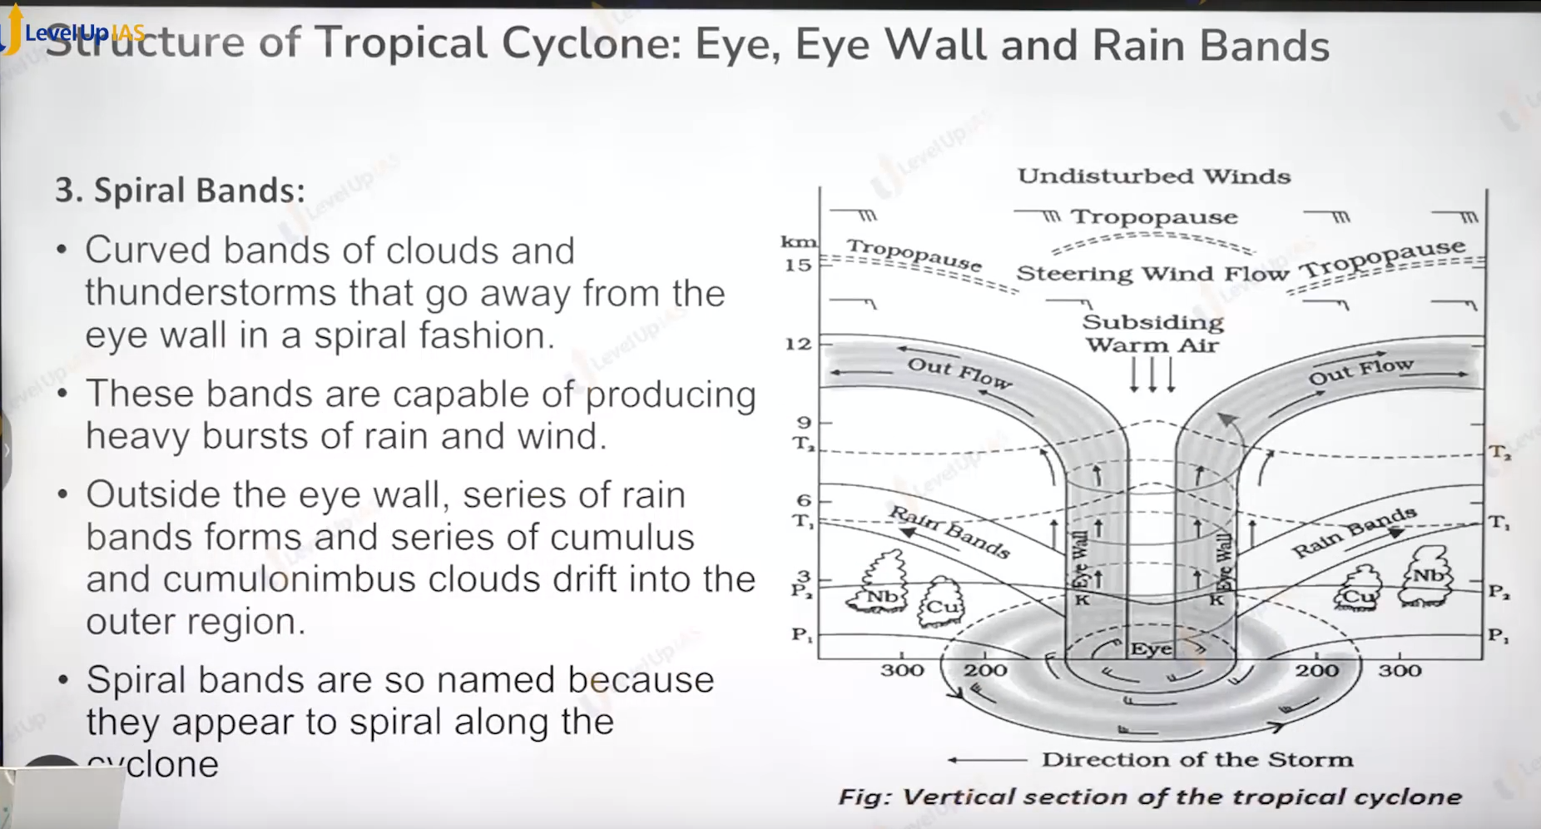

Eye

1. Eye is roughly circular are at the center of tropical cyclone with comparatively mild winds
2. There is little to know precipitation in the eye.
3. Eye is the area of lowest pressure zone. And with the warmest temperature.

Eye wall

1. Eye wall is roughly a circular area that surround the eye with speeriing and raising air.
2. Eye wall has stronges sufaces winds the winds reaches the velocity of 250 km per hour.
3. To torrential rainfall occurred

Spriral bands:

1. The curly band of cloud they are moved along with the cyclone.
2. They are also called rain band.

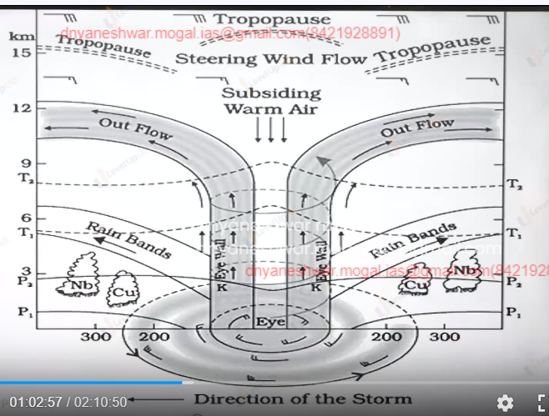

Weeding ground and the local name:

Weeding ground are Caribbean sea, way of Bengal , Arabian sea towards north of Australia, south China sea.

1. Southeast carribbean region
2. Phillipn island
3. Sough china sea
4. Way of bangal and arabian sea
5. Towards madagaskar also north west of austrilia

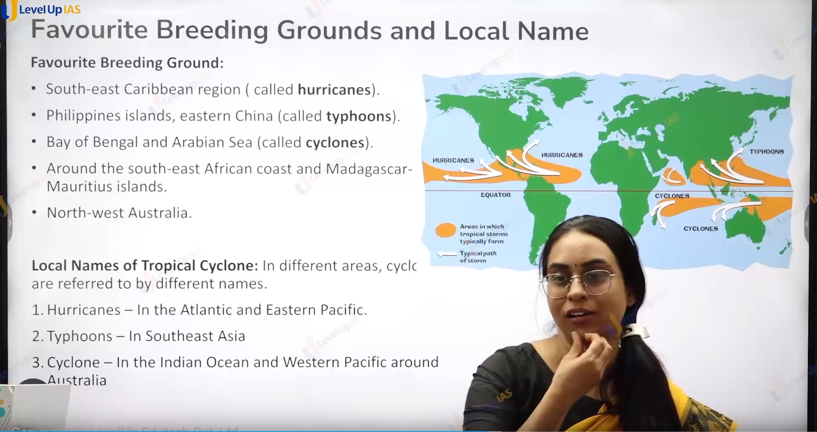

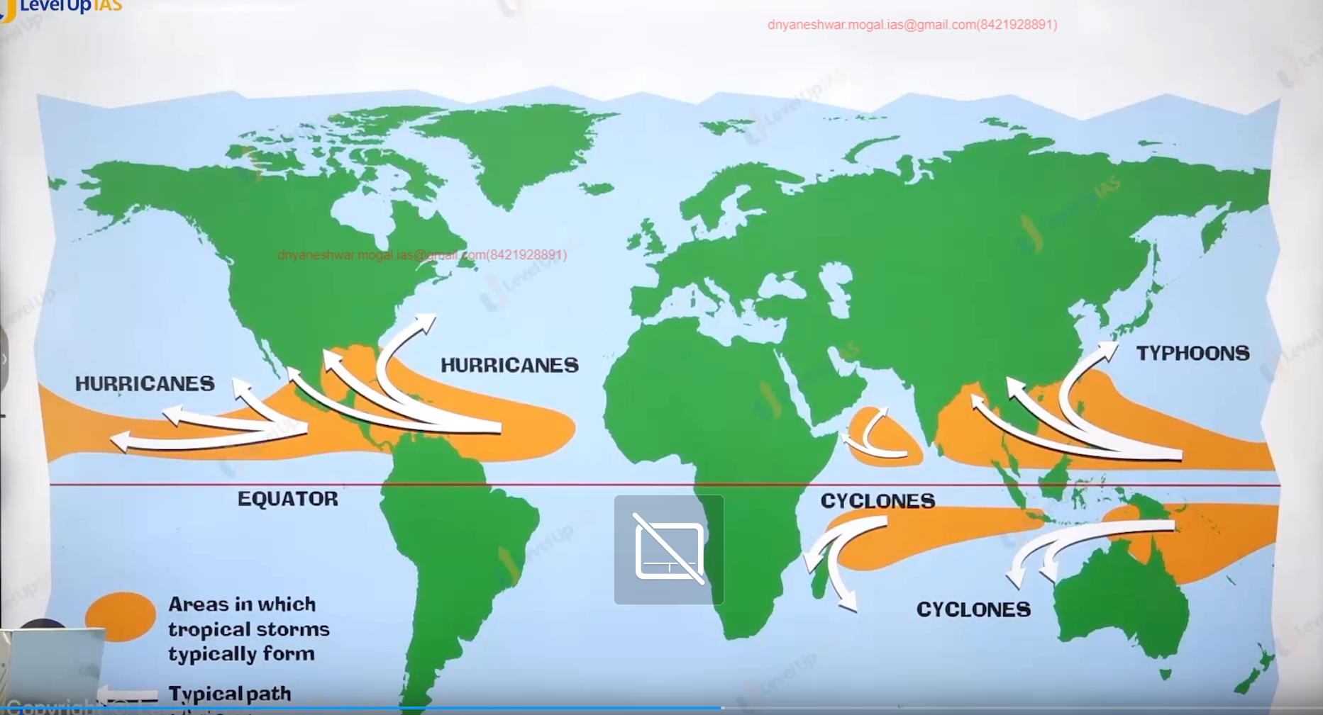

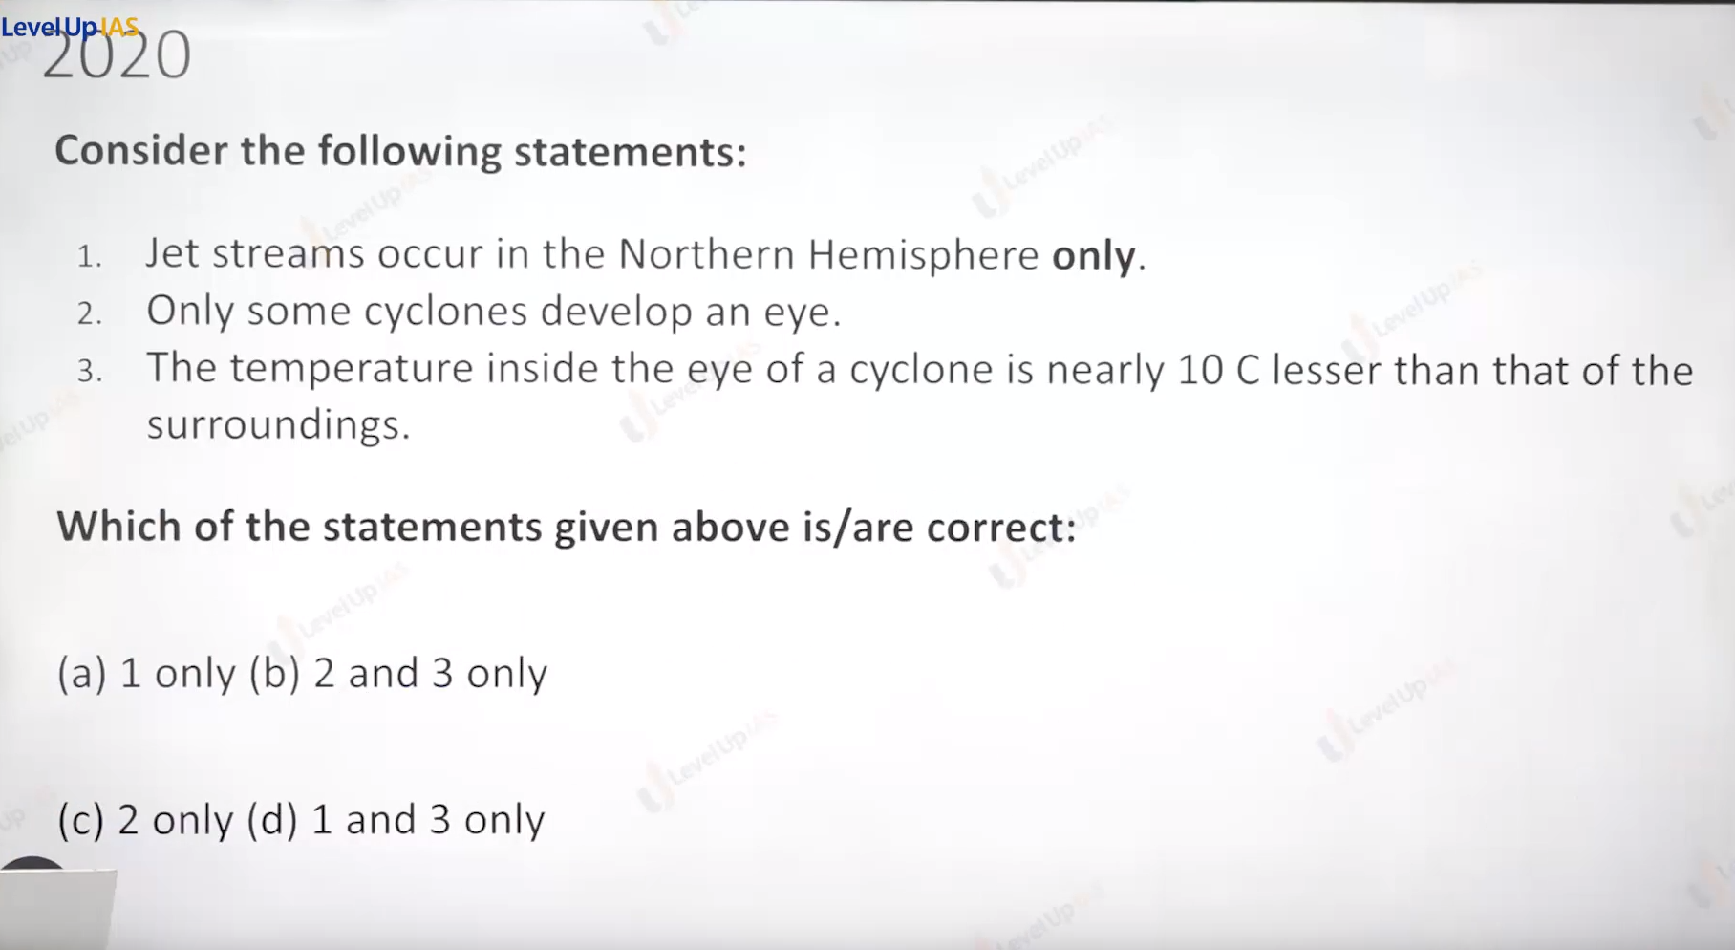

Jet stream develop in the both hemisphere, it develop in the upper part of atmosphere in the tratosphere.

Extra-tropical cyclone may not have a eye, they are develop due to warm and cold fault of air mass.

Eye is warmest and low pressure site in the cyclone.

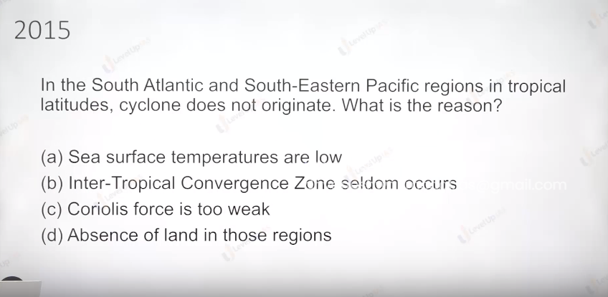

Ans is b ITCZ mainly responsible for cyclone.

Cyclone mitigation and disaster preparedness:

1. Early warning system: tracking the path of tropical cyclone understanding the land fall, know the speed of cyclone etc.
2. ISRO has done fairly good work as the casualty is reduced to nearly zero.
3. Regulating the land leaves groves ex. Enforcing building code, coastal zone regulation, that is depending on the hazards prowess developmental activity should be modified.
4. Engineering solution ex construction material should be cyclone material, water resistance.
5. Shelter belt in the form of forest belt specially mangroves wetland to prevent coastal erosion
6. Community participation: community is first responder.
7. Color coding the cyclone: IMD (Indian meteorological department) issue the warning to alert warning from the natural hazards 4 color are used red, yellow green violet and orange.
8. Violet means tropical cyclone can arrive in the next 6 hours meaning seek the shelter.
9. Red means cyclone conditions are expected within 36 hours. It signifies the warming to protect oneself from cyclone
10. Orange means tropical cyclone conditions are possible within 48-hour orange signifies preparing oneself from cyclone.
11. Yellow signifies that the tropical cyclone prosses the treath and yellow means to be alert.
12. Green means no hazards

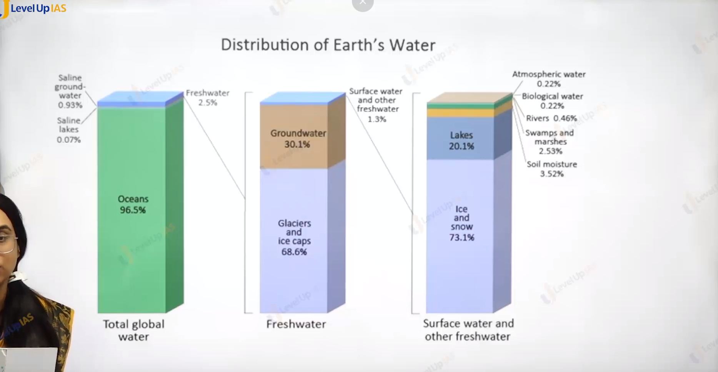

Moisture in the atmosphere:

1. Distribution of earth’s water
   1. 96.5 of the water in the oceans fallowed 1 percent of water in the saline lake and saline ground water. And 2.5 percent of water is fresh water.
   2. Out of 2.5 percent of water which fresh water. majority of water found in
      1. Glaciers and ice caps
      2. Ground water
      3. Fallowed by lakes
      4. Water in the atmosphere
      5. Followed by the water in the river.

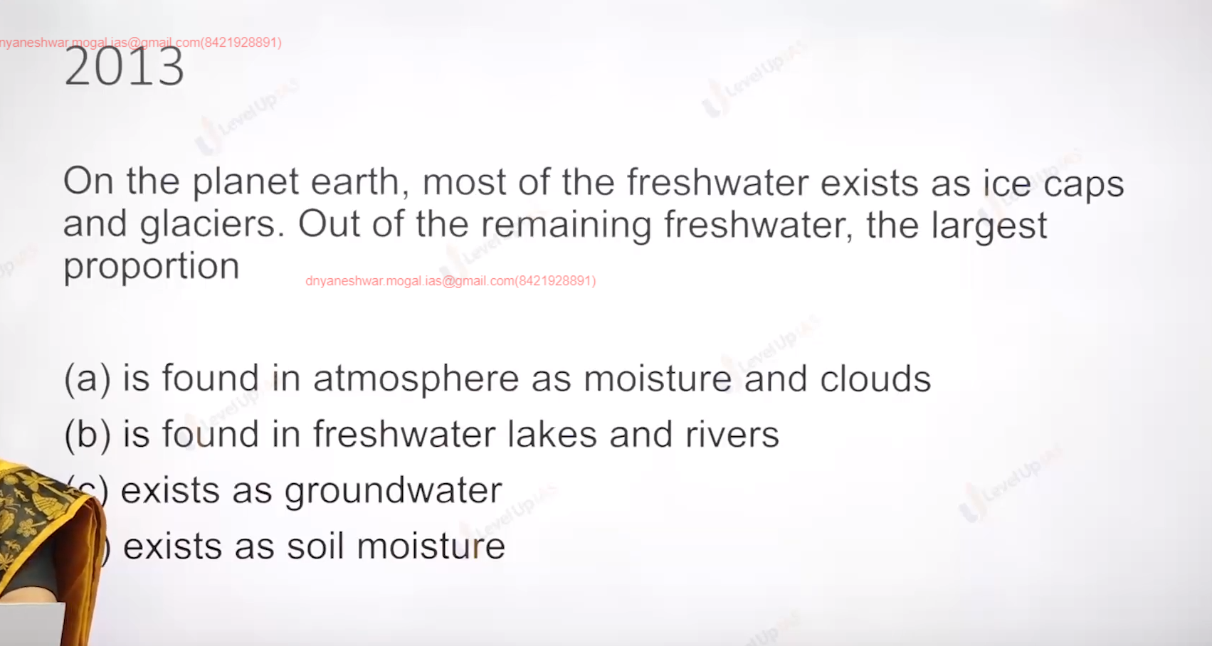

* 1. Ground water

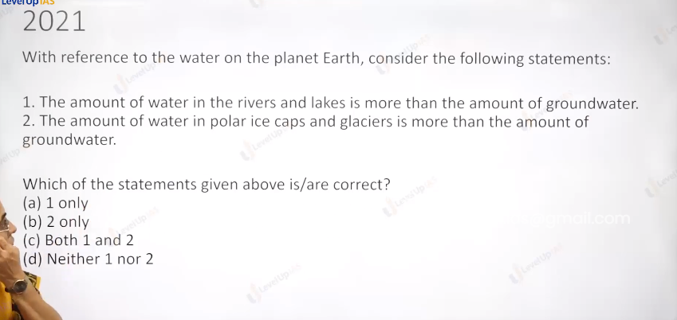

* 1. Only 2 , polar 70 and around 30 ground less 1% are in he river and lake atmosphere.

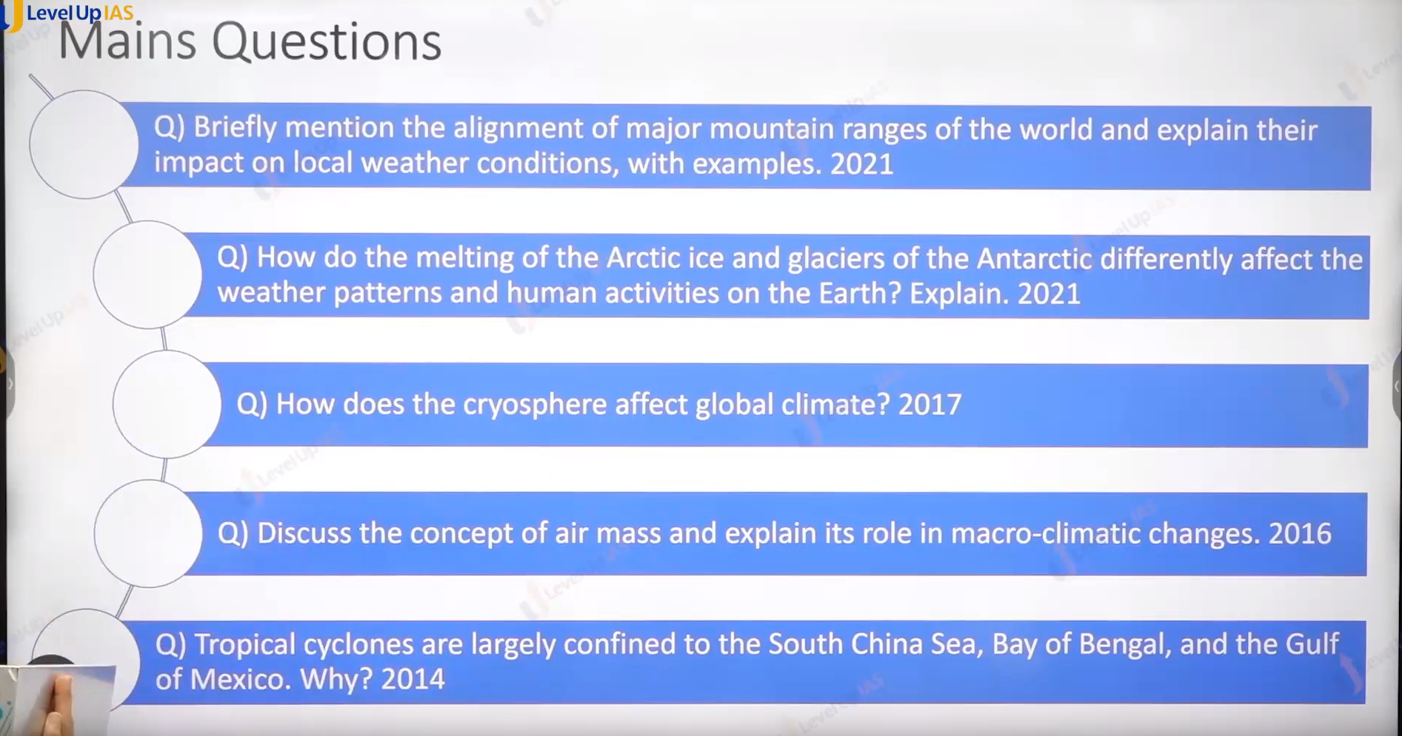

1. Melting of arctic ice and Antarctic.
   1. They have the different effect on the weather changes and human activity.

4 air mass and role in the macro-climate changes.

Continental polar air mass , maritime tropic create cyclone.

5. condition cyclone itcz

Condensation, precipitation:

Condensation:

1. Conversion of water vapor to tiny water droplet as air raised it cools leading to saturation of air leading to condensation and precipitation.
2. Condensation can take place at or very near to the ground surface ex dew fog, mist. Frost( water to ice)
3. Condensation at the higher height it found the cloud.

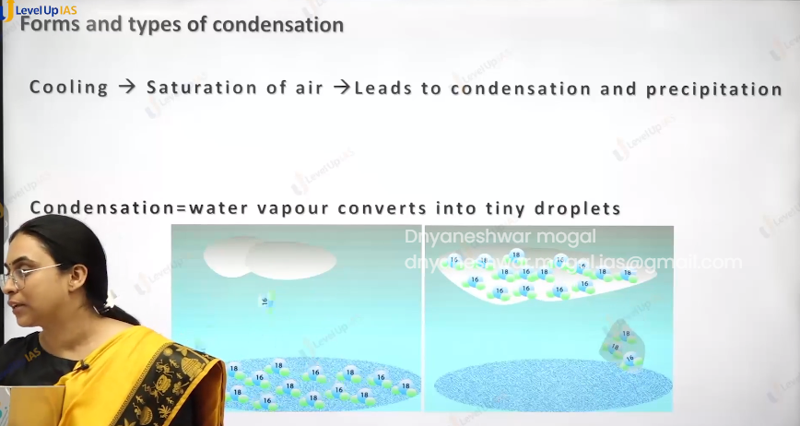

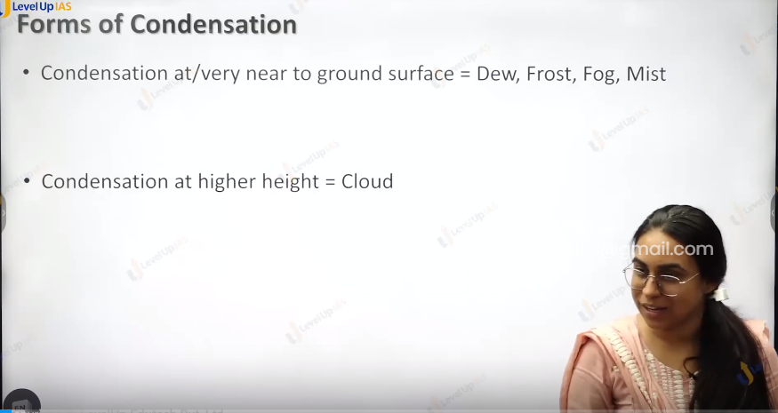

DEW:

1. It refers to the direct deposition of water vapor in the form of water droplets on the surface like grass plant, soil.
2. Conditions are
   1. Air above the ground in winter it become very cold and unable to hold the cold and deposits the water vapor on object
   2. Conditions needed are clear sky, calm air, relatively high humidity, cold and long winter nights.
   3. In dew condensation occurred above the freezing point.

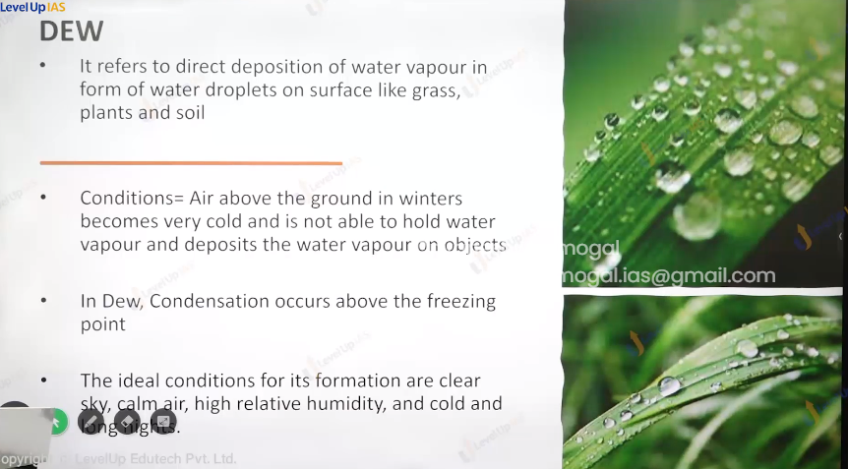

**(23) Condensation, Precipitation**

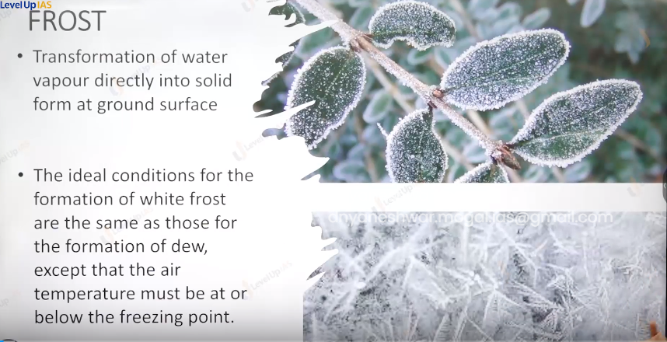

Frost:

1. Transformation of water vapor directly into solid form at the ground surface
2. The ideal condition for frost are same that of dew except the temperature must be at below the freezing point.

FOG & MIST

1. The condensation of water vapor into water droplets on the condensation nuclei like dust particles, smoke, etc. suspended in air.
2. These condensation nuclei have a tendency attract the water and therefore they are also called as high grow scope nuclei this suspended water droplets forms fog and mist.
3. Fog and mist are suspended water droplets in the air and therefore they reduce the visibility.
4. Mist has moister as compared to fog.
5. Mist has microscopic water droplets as compared to fog.

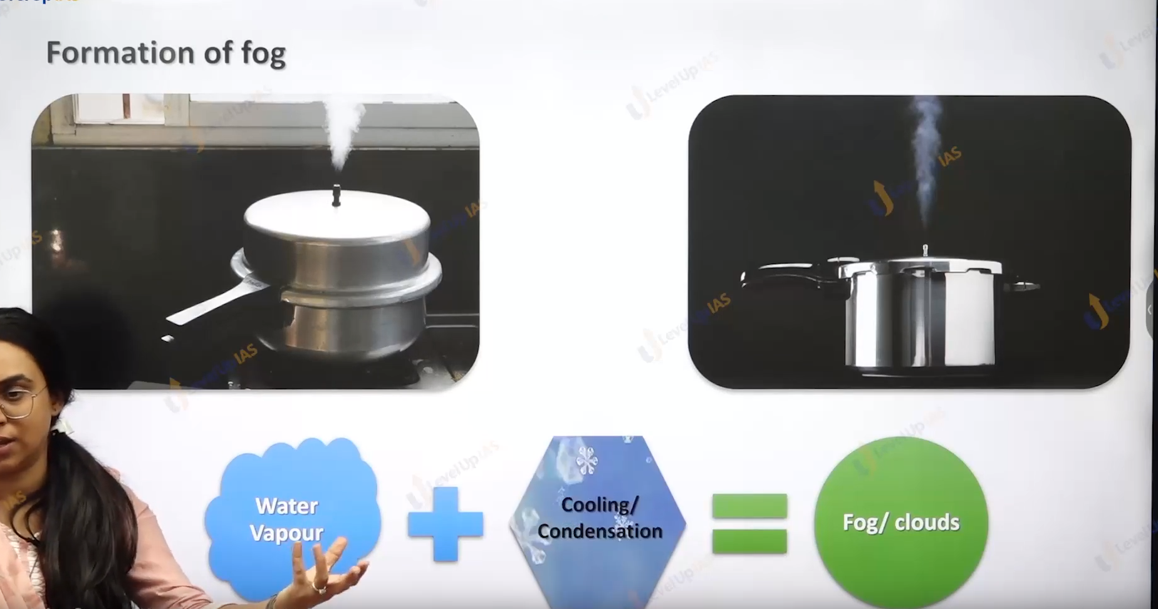

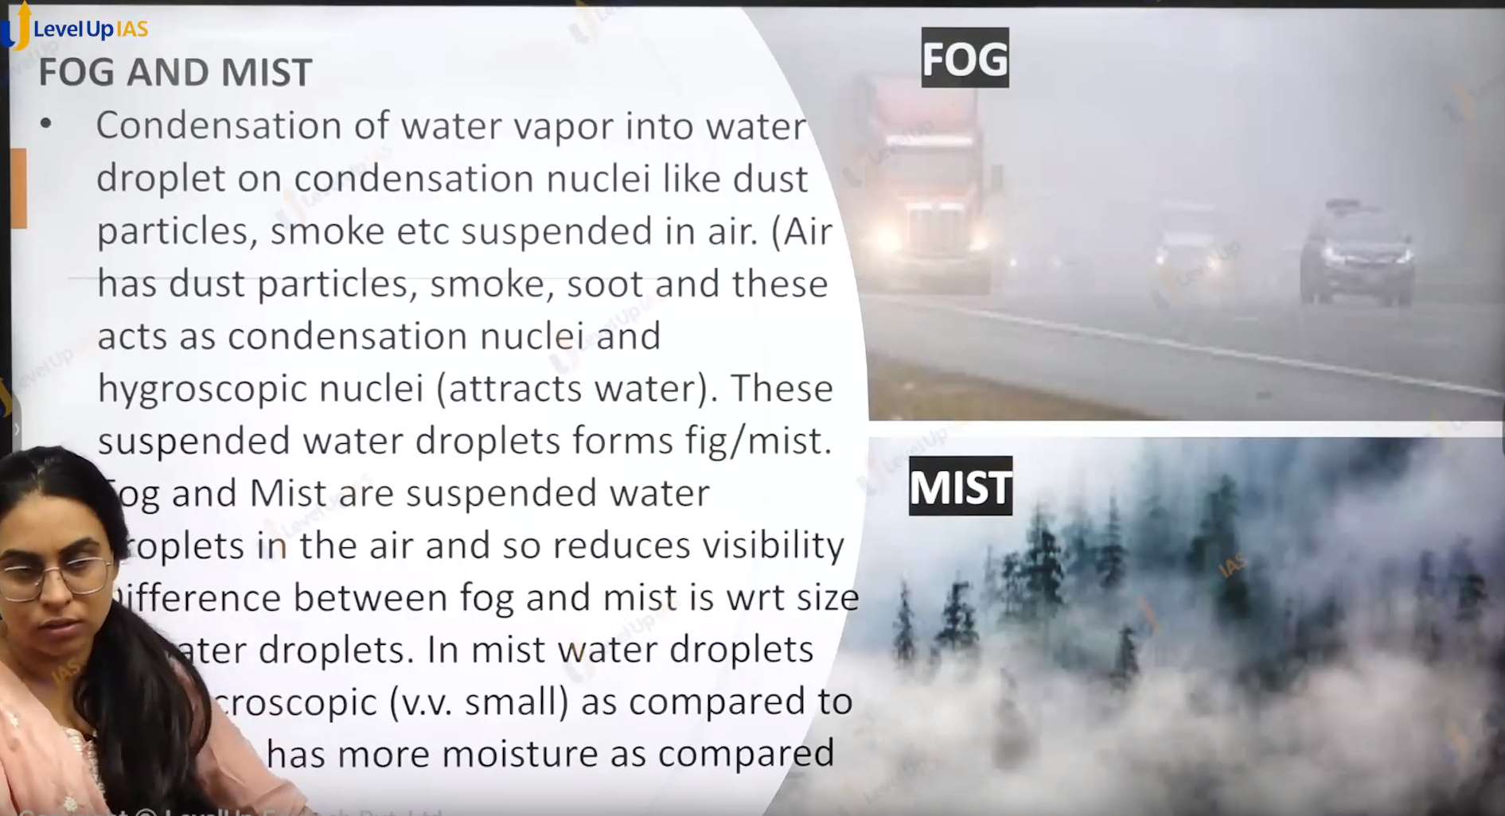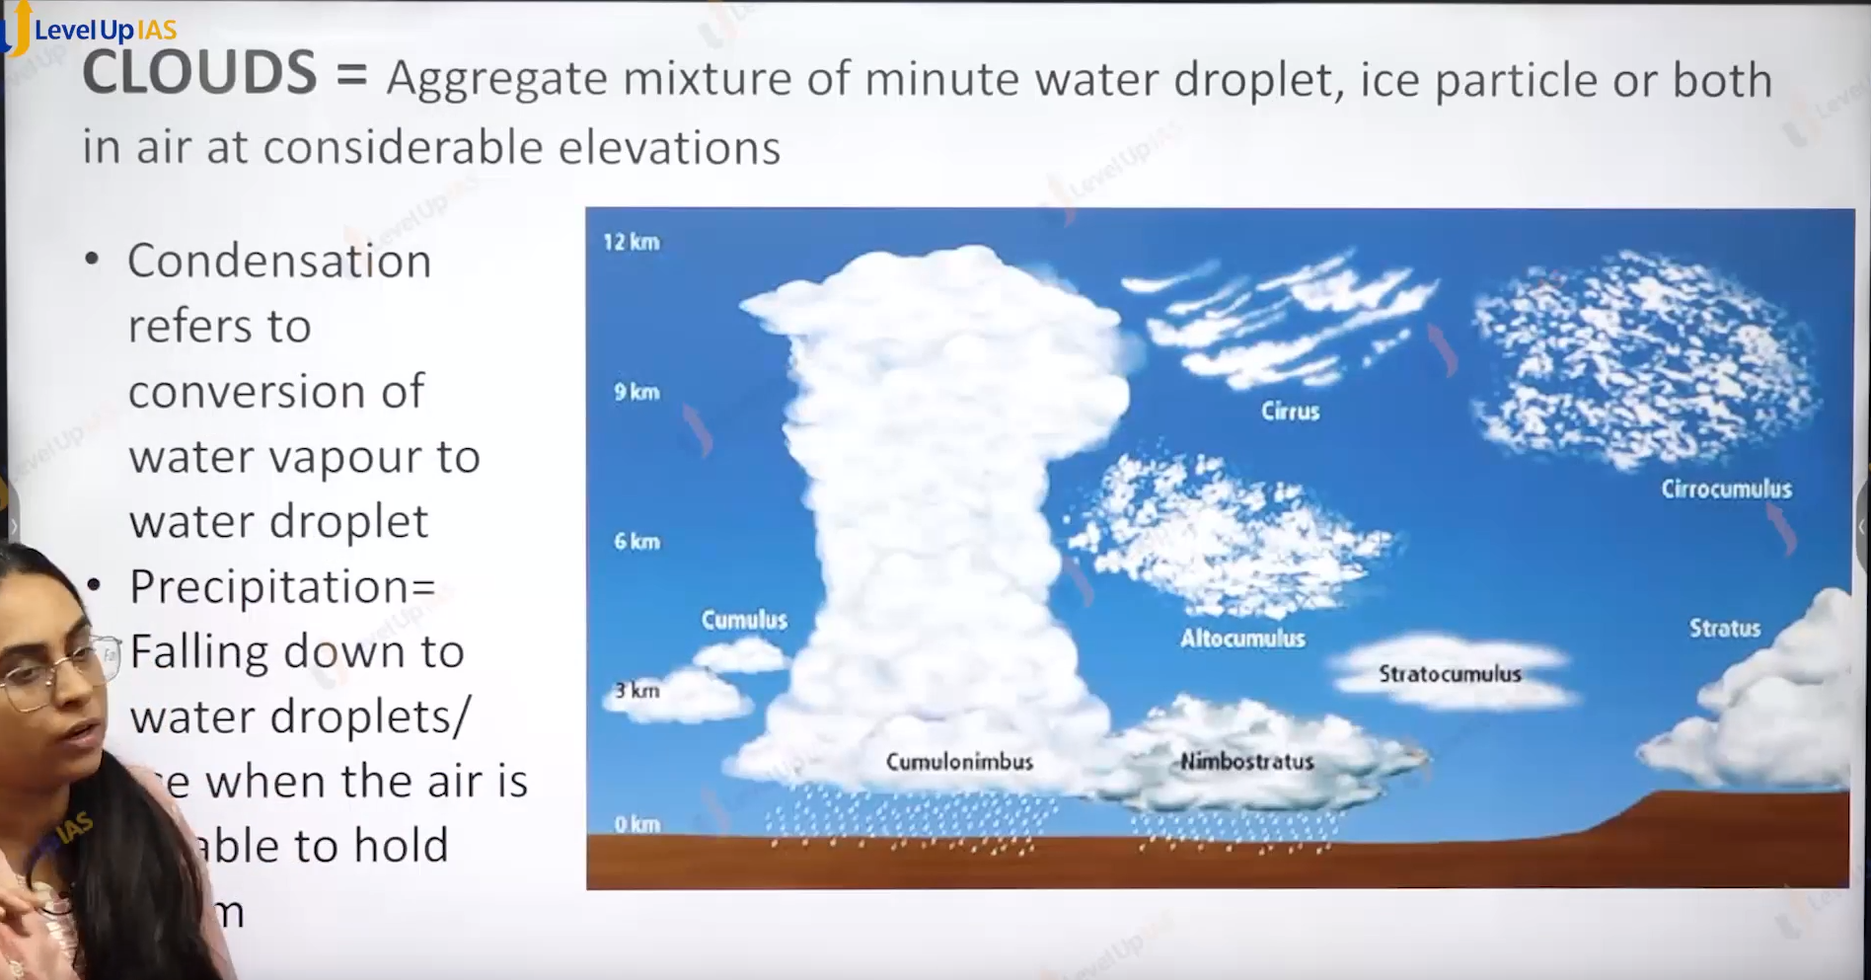

Cloud:

1. Here in the cloud Condensation take place at the higher height.
2. Cloud refers to aggregate mixture of minute water droplet, ice particles or both. found in the air at considerable elevations.

Type of cloud:

1. Cirrus:
   1. high altitude clouds were found around 6-10 km altitude.
   2. They are thin cloud and white cloud.
2. Alto:
   1. It is a medium level cloud. Found at an altitude of 5 km.
   2. Low level clouds are mainly stratus clouds.
   3. A cloud with high vertical clouds is cumulonimbus clouds
3. Cumulus clouds: cumulus means wooly or bumpy.
4. Stratus implies thin sheet.
5. Nimbus: Rain bearing,

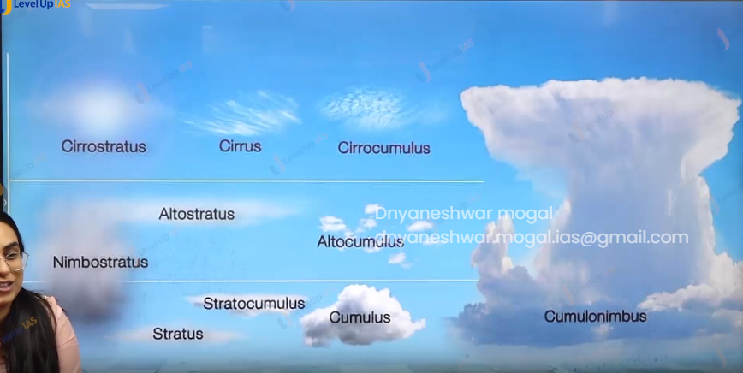

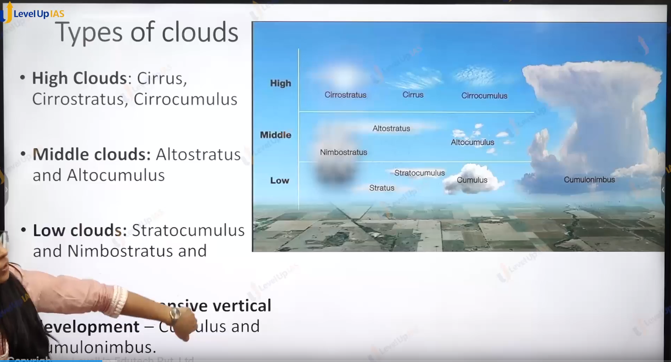

Type of cloud:

1. High cloud: cirrus cirrostratus, cirrocumulus.
2. Middle level cloud: altostratus, and altocumulus.
3. Low level cloud: stratocumulus and nimbostratus and stratus, and cumulus
4. The cloud very extensive vertical extencts is cumulusnibus cloud will shape cloud.
5. Cirus :

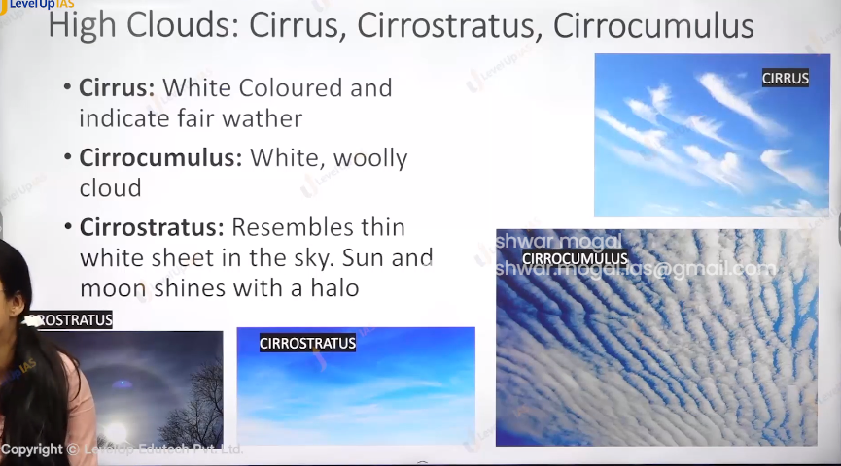

1. Cirrus:
   1. White colour cloud and indicate fair weather.
2. Cirrocumulus:
   1. It is white and woolly and bumpy cloud.
3. Cirrostratus :
   1. It resembles thin white sheet in the sky. Sun and moon shines with hallow. Halo.



1. Alto stratus :
   1. They are medium level dance cloud.
2. Altocumulus:
   1. It is white woolly bumpy cloud.

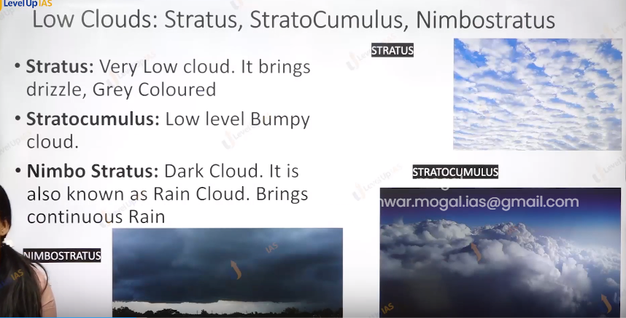

1. Stratus :
   1. They are very low cloud. It brings drizzle(minute droplets), grey color.
2. Stratocumulus : low level bumpy cloud.
3. Nimbo status: dark cloud . it is also called as rain cloud and it bring continuous rainfall.

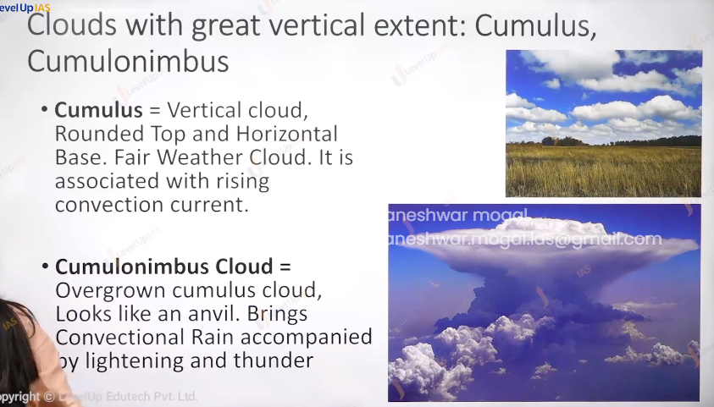

1. Cumulus:
   * 1. Vertical cloud with rounded top and horizontal base. It is fair weather cloud and it is associated with raising conventional current.
2. Cumulonimbus cloud:
   * 1. It is overgrown cumulus cloud it looks like anvil and bring convectional rainfall accompanied by the thunder and lightning.

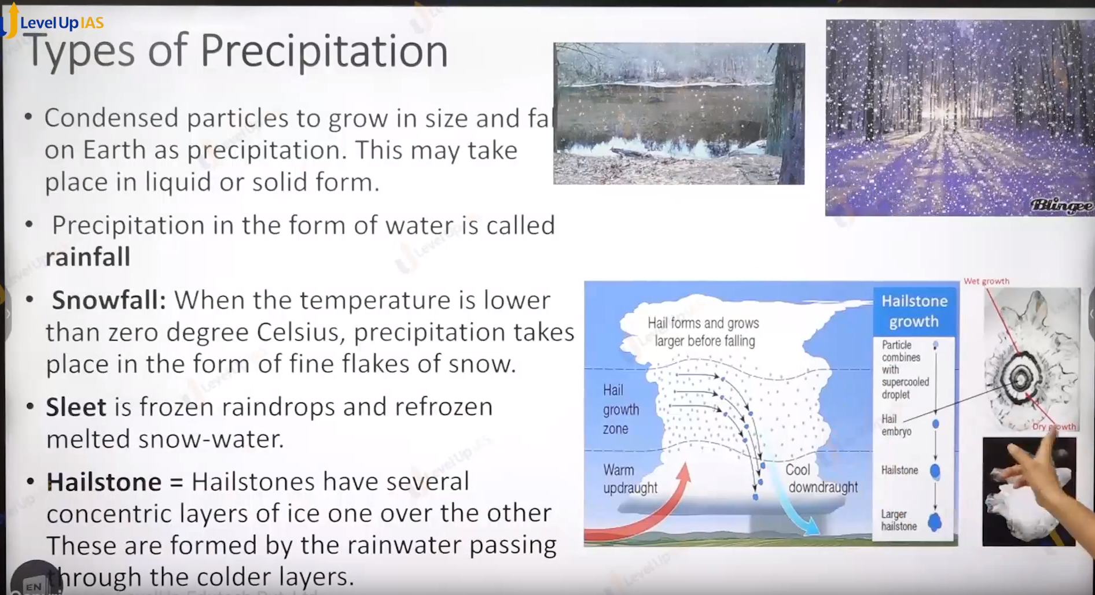

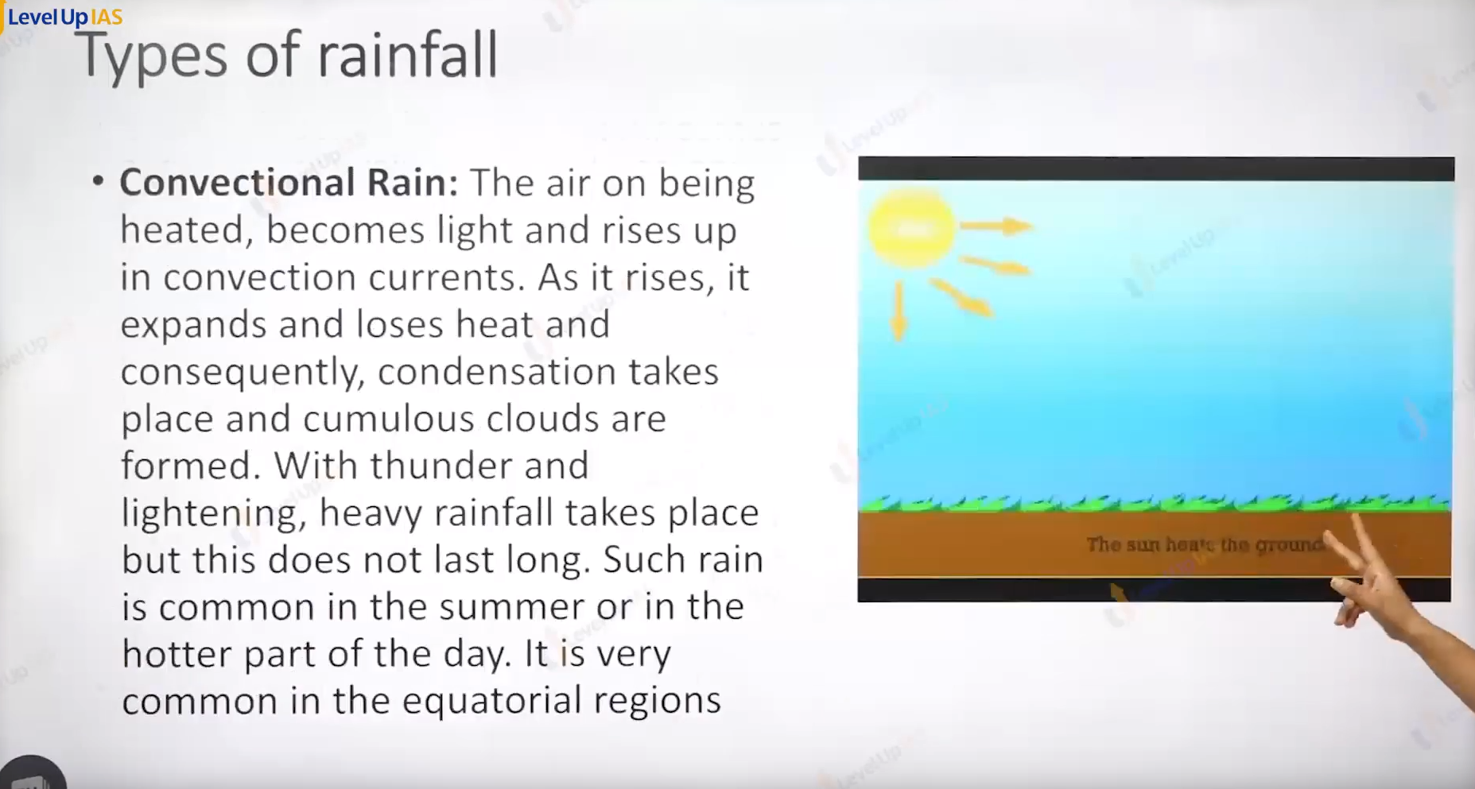

Precipitation:

1. Condensed particles can grow in size and fall on earth as precipitation.
2. This makes take place in liquid or solid form
3. Precipitation in the form of water is called rainfall.
4. Snowfall:
   1. When the precipitation takes place in the form of fine flake of snow. That is temperature is less than 0 degrees Celsius.
5. Sleet: it is frozen raindrops that melt on the way and refreeze on coming in contact with cold air above the earth surface.
6. Hail stone:
   1. It has concentric layer of ice on over other.
   2. The server coating of ice is formed because water vapor experiences many updraughts and downdraughts in the cumulonimbus cloud.

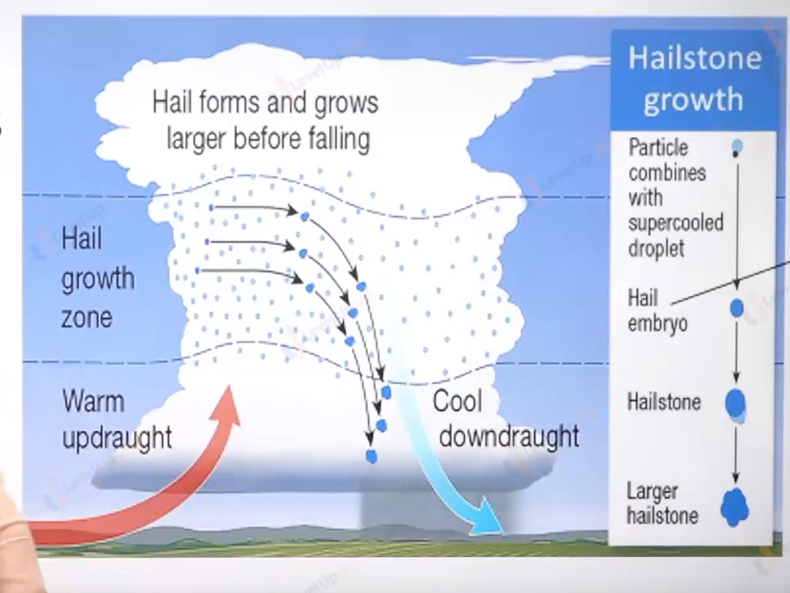

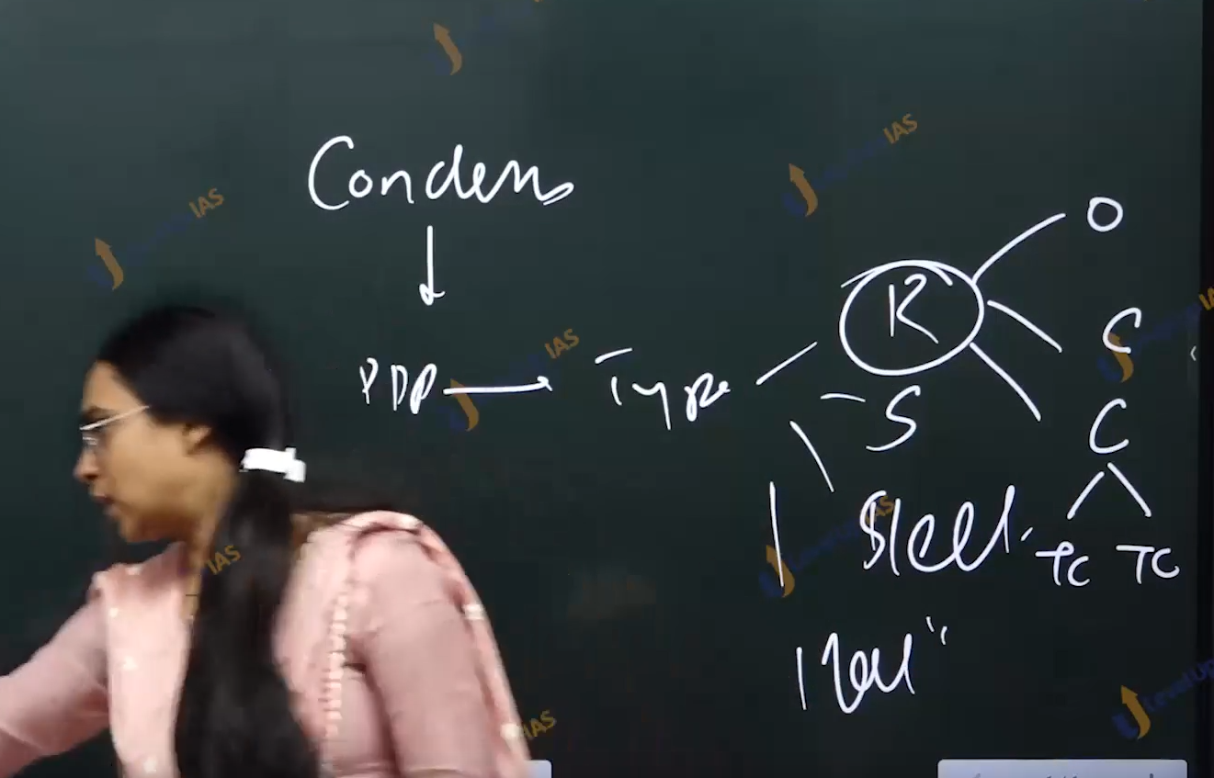

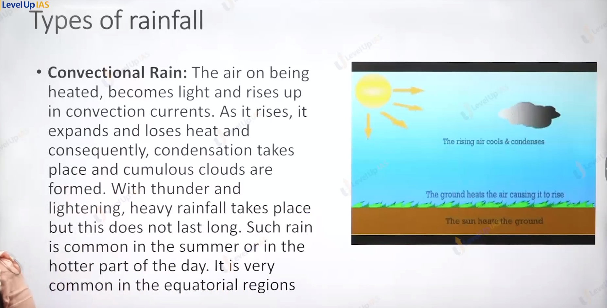

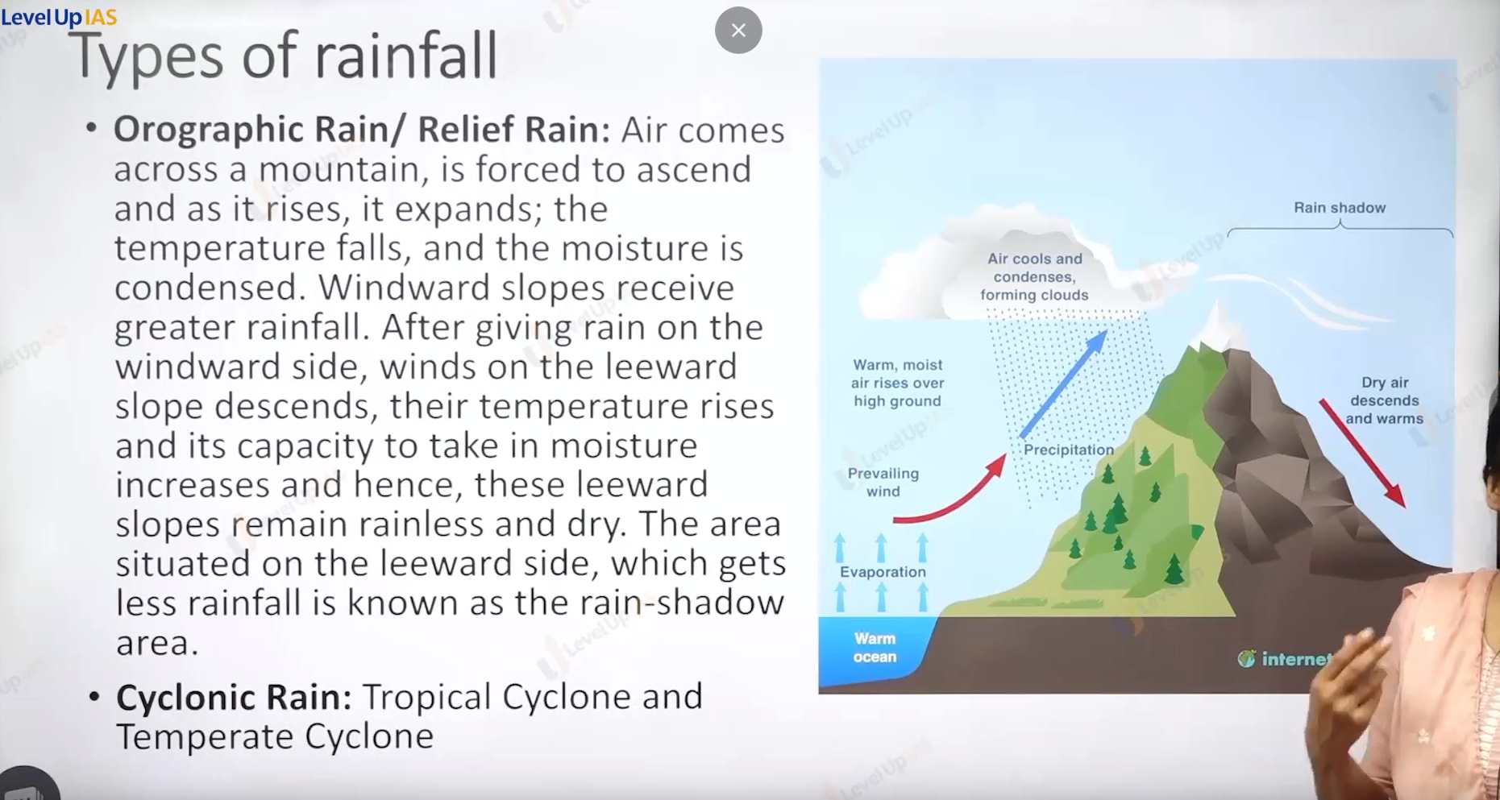



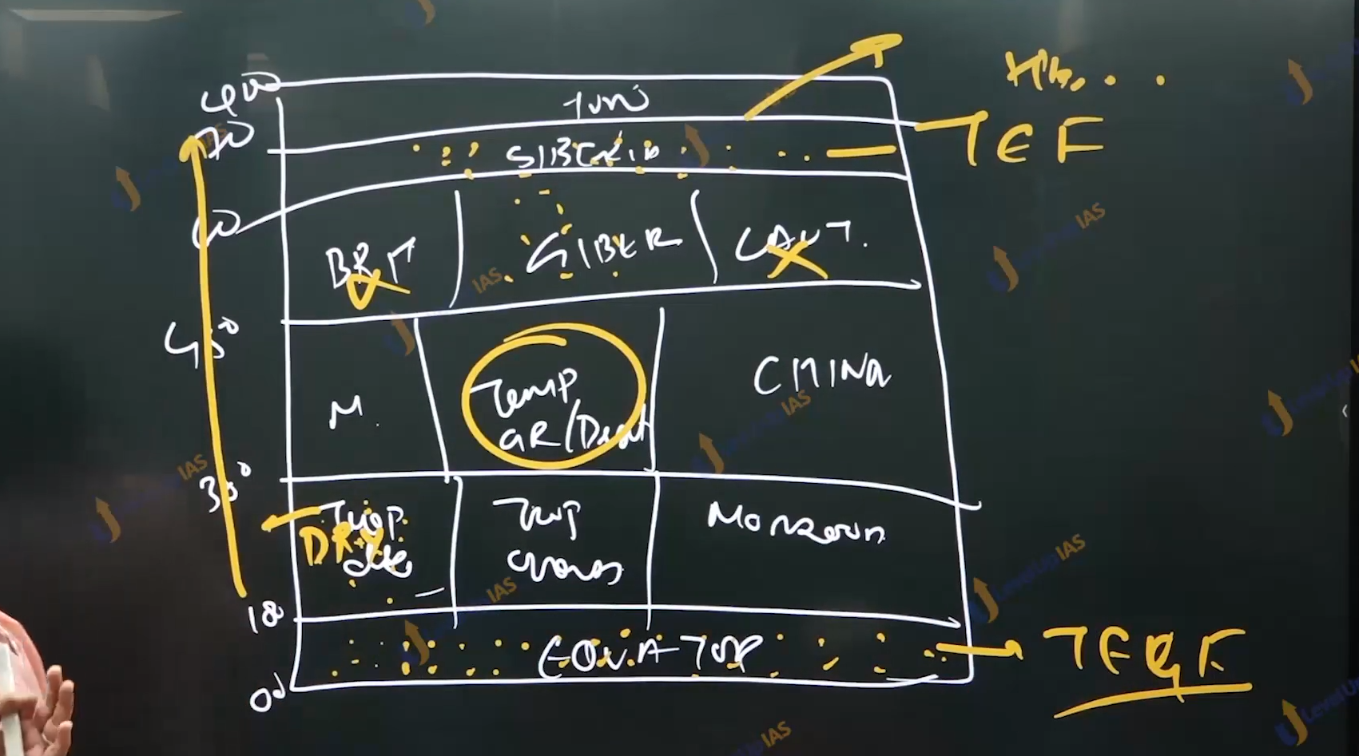

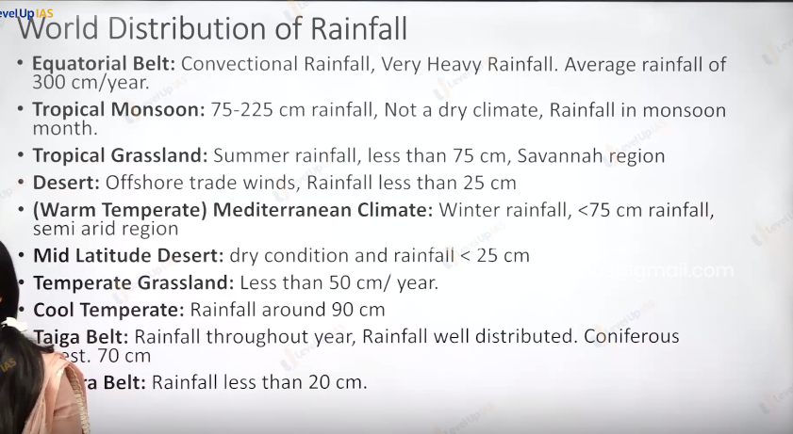

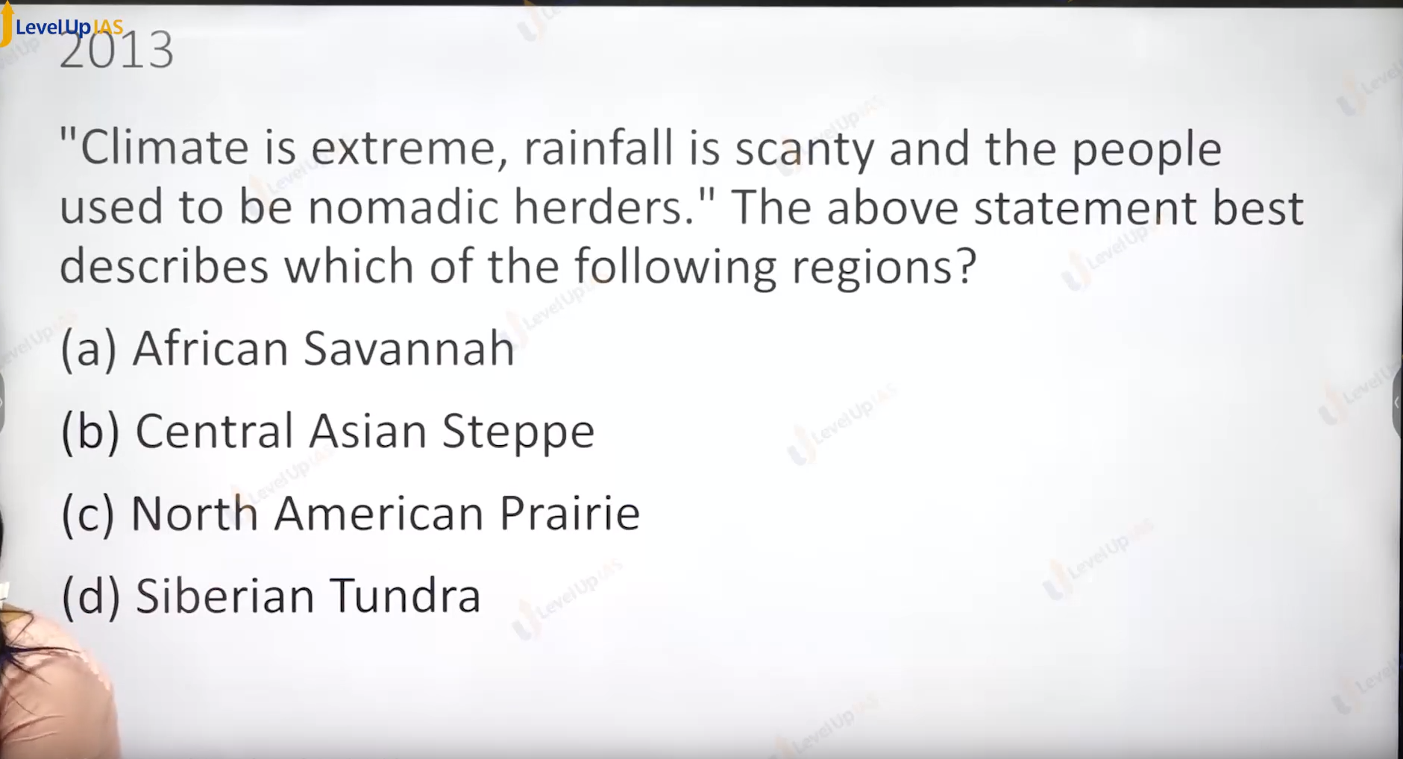

Ans b apply the answer. Try to eliminate option on the information.

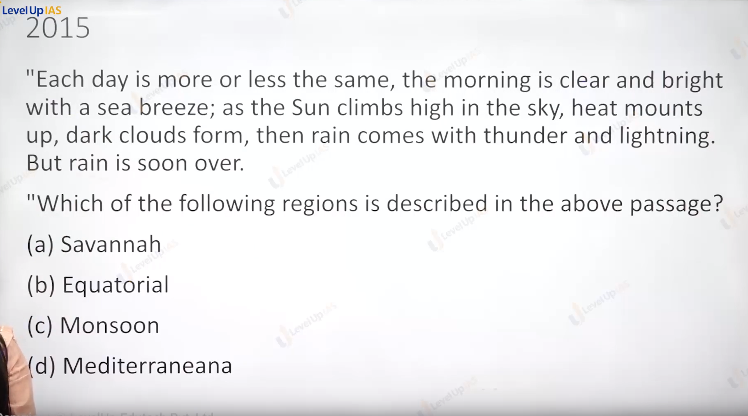

B. equatorial.

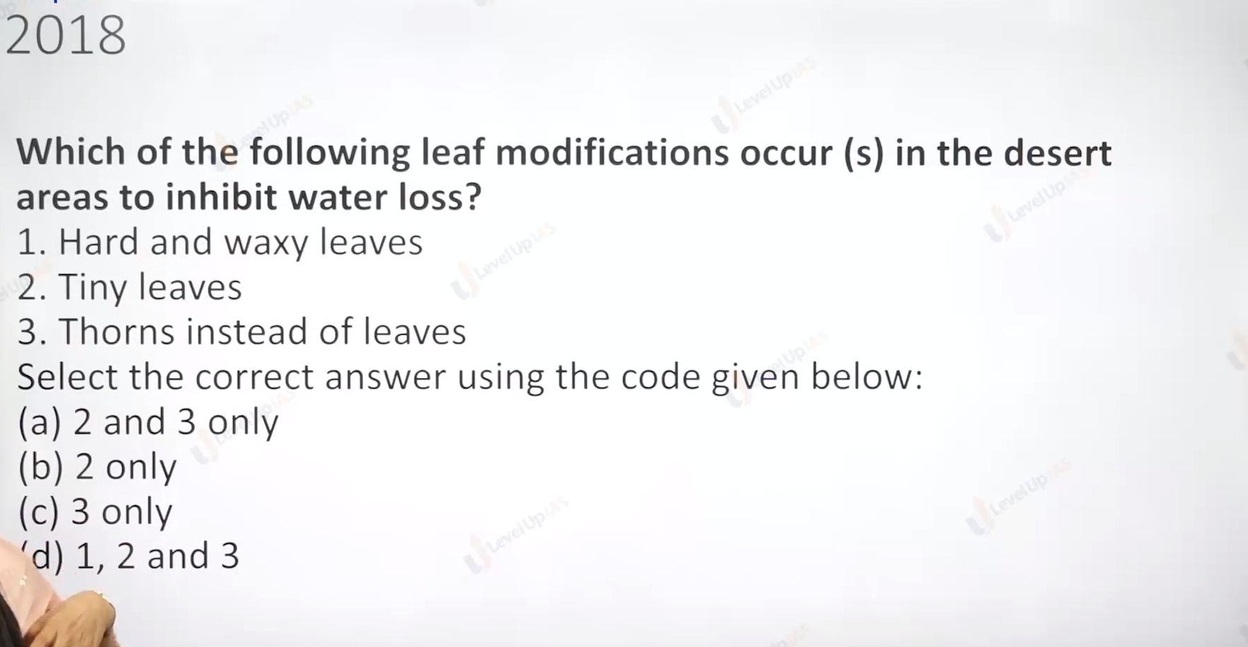

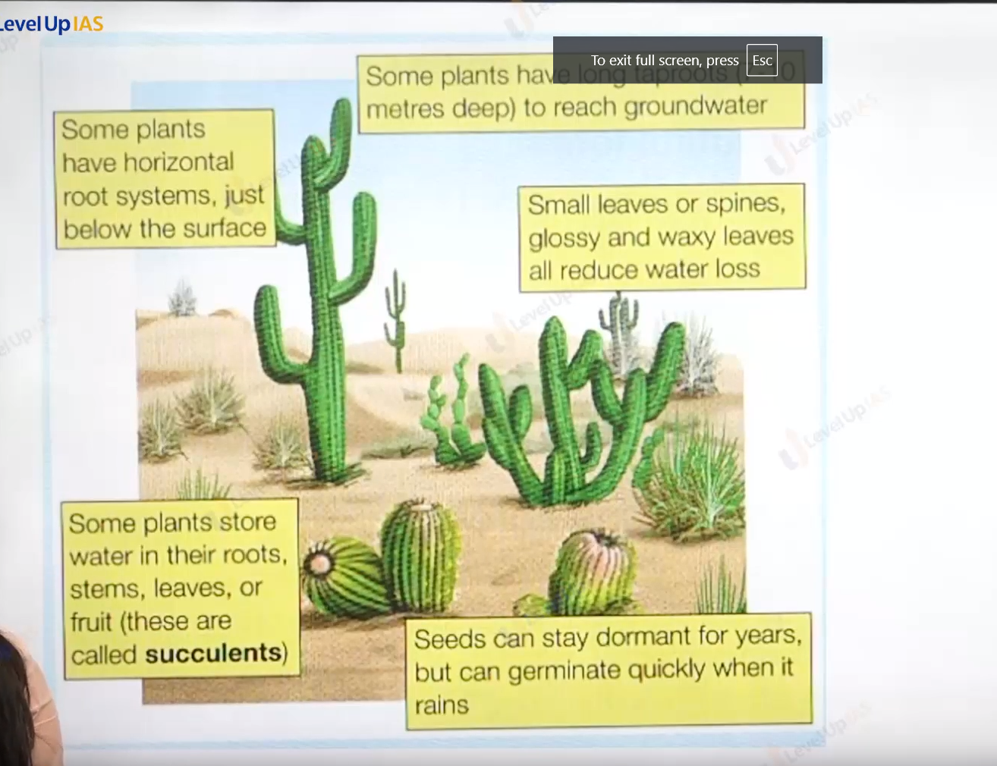

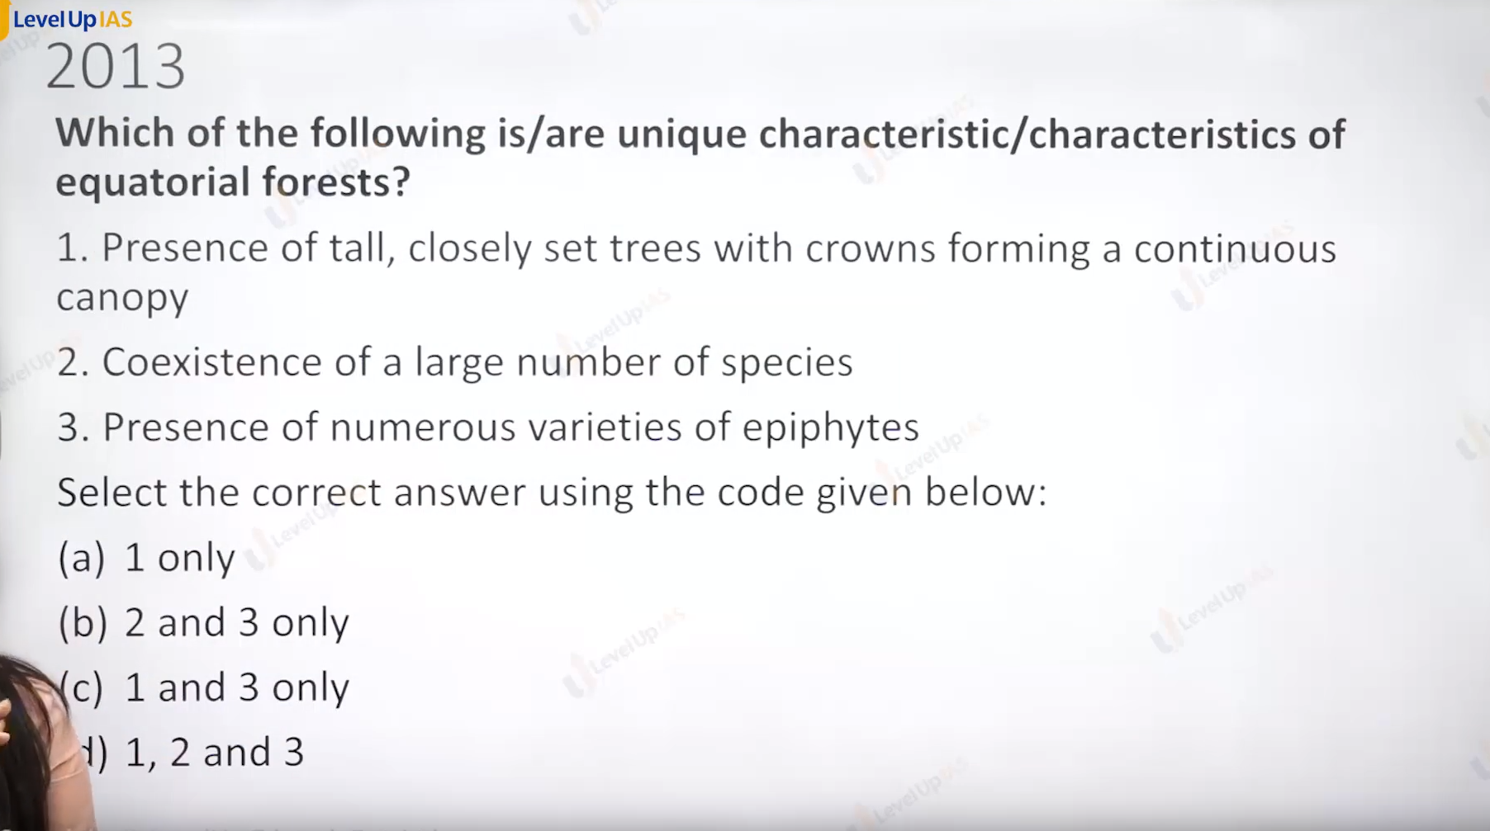

Ans D.

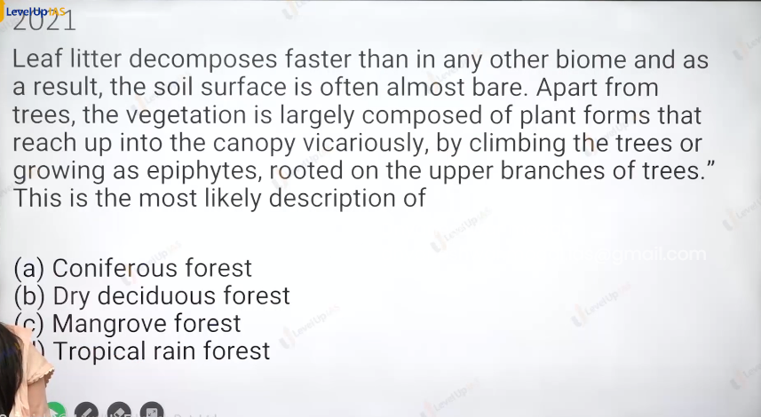

Answer: